**JAIPUR INTERNATIONAL PUBLIC SCHOOL**

**KANTICHANDRA ROAD, BANIPARK, JAIPUR 302019 Mob. No :- 9982000098**

**CBSE affiliation No. 1730653**



**Class X CBSE Board Examination 2024**

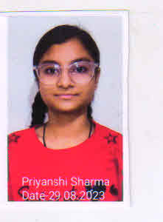

**Social Science – 99, Hindi – 94, Science – 93,**

**Like previous year, this year also no students failed**

**Following students secured above 90% in one or more subjects.**

 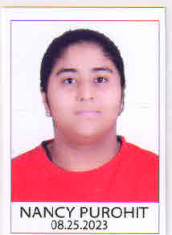 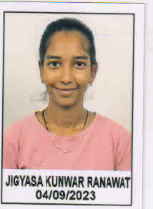

**Science – 92 Social Studies – 91 Hindi - 91**

**Social SCIENCE - 96 Hindi – 93**

**CONGRATULATIONS to all students, Teachers and Parents.**